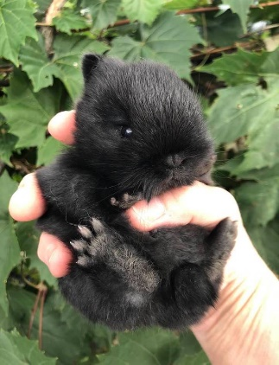
** Fluffy Misfits Rabbitry**
Sold To: __________________
Sire:_____________

Color: ____________

Name: ____________
DOB: _________________
Color: _________________
Sex: _________________
Dam: _____________

Color: _____________

